Question for Middle Manager

- Would you share with us the business objectives 东方大唐?

- Could you tell us the responsibility of the EPG, and its relationship of the process improvement of 东方大唐?

- How often did your organization conduct internal process review (internal Appraisal), did the internal review effective, how does the organization handle the items identify as opportunity to improve. And how are they deployed?

多久进行一次内部评估？ （第一年评估是差距分析，由咨询老师根据CMMI模型来分析。2018年5月份计划进行正式评估，由CMMI主任评估师负责）内部的评估或评审是否效？ 评估发现的改进建议如何进行处理（差距分析结果，直接输入到体系建立中。18年评估的改进意见，记录到《改进信息跟踪表》，EPG进行分析并优化体系。EPG定期（每季度）对过程改建议进行分析讨论，对于接受的建议会纳入到过程改进计划，并分配到相关人员负责改进；不接受的建议反馈给提出人。）？
如何推广和部署？（体系建议后，有体系的培训和试点。 体系修改后，也有体系发布通知）

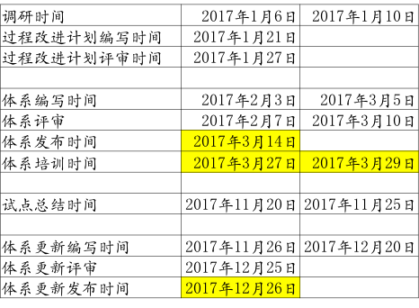

- Could you tell us your involvement in the project of your PM? What do you expect from your project managers in regard to the managing their project, is there any project objective in regard to schedule and/or defect? What are organization objective? And what type of information did you get periodically?

在项目中参加哪些活动？希望项目经理怎么管理项目？对于项目进度＼质量的组织目标是什么？ 能得到什么定期的汇报？

在项目中的活动：
1．项目启动会；
2．参加计划的评审，批准整个项目计划；
4．要参加里程碑会；
5．项目结项总结会（可选）
6．项目出现重大变更或风险或问题，参与决策，帮助协调解决问题

项目进度，项目启动时间，项目验收时间
质量：不能遗留严重和致命缺陷

项目组有周报，里程碑报告会发送给中层

需求变更：项目在设计阶段有一个需求变更，具体看项目变更申请表

- In regard to training, do you feel that your people had adequate training in the project application domain? How about the technical knowledge? Have your PMs received adequate project management training? And HR training?

- Do you feel your people are motivated to practice the process improvement? Why do you feel that way? Did you ever receive any complain?

- Did you ever receive the measurement & analysis report from your project, in that report, which information is useful to you? Are there any measurements data that you wish to have are not collected? How does this measurement data map to organization business objectives (Productivity rate; Defect removal rate, Product quality), how important are those measurements?
有没有收到项目提供的度量数据？你最关注哪些数据？这些度量数据如何与你的商业目标对应；

度量数据：
里程碑报告; 《项目度量分析表》

哪些指标对你有用？
如：进度：要知道对应哪个模块？
哪些数据是你想看到，但没有的？
自由发挥（但要度量数据里没有的）

关注组织生产率：(人时\功能点)：7.17，目前项目也是使用这个生产效率进行估算
目前项目规模：645FP

- Do you feel that PPQA group is effective? What else do you like them to improve?
你觉得QA有效吗？

有效。
建议：
QA对业务知识更多的了解

QA工作如何汇报给管理层？
组织级QA：每个季度检查EPG运作和项目QA的情况，发报告给管理层
项目QA：项目每个里程碑发QA工作报告给管理层
关注不符合项是否按计划解决，是否有问题需要管理层协调。

- Did you participate in Milestone review? How about plan review?

有参加里程碑评审，也有参加计划评审；
注意参与人，评审内容。

- How does the risk management being implemented in your orgnization?
项目中风险管理？

组织中有个风险库--《项目常见风险列表》；项目策划和风险识别时使用。
每个项目都有一个风险计划《北京汽车集团有限公司资源管理平台项目_风险管理列表》；分析发生概率，影响程度，确定风险等级
关注项目高级别的风险。

- Is there any guideline for DAR in your organization, could you briefly describe the guideline for us, has any of your project perform the DAR. Do you remember the selected solution?
决策分析，项目如何做决策分析?

组织中有决策分析与决定指南，决策分析和决定过程；
以下情况遇到多个解决方案时,需要进行决策分析活动
- 关键技术方案选择（项目）
- 供应商选择
- 项目重大变更
具体看项目决策分析报告

- How confidential material does is handling in your organization? Do they meet your security requirement? Are they any improvement you wish to have in this area?

公司文档资料的保密定义

公司有保密要求，分成4个级别（外部公开、内部公开，机密，绝密），项目文档都是内部公开，合同是机密，商业策划和成本是绝密

组织架构:

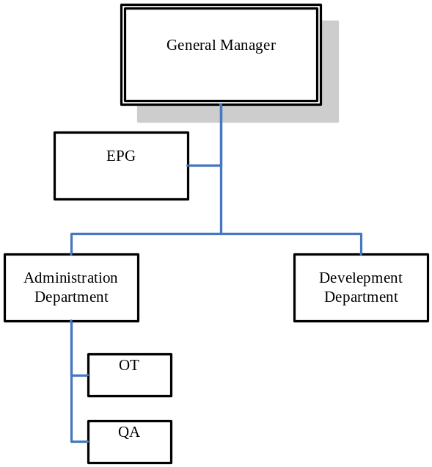
Area / Function | Total
Development Department | 10
Administration Department | 1
EPG | 2
OT | 1
QA | 1
Total | 15

